Week 5 – Role and Access Testing

- Access role table
First I reviewed the source code of the Phionix project and took notes on what each role is allowed to access or blocked. The table below showed the expected access based on the code. After that, I tested the role using Postman and compared the result with the expected access.

Page | Admin | Analyst | End User | Ingestion service
Dashboard | Allowed | Allowed | Allowed | Allowed
Threats | Allowed | Allowed | Allowed | Allowed
Hazards “GET” | Allowed | Allowed | Allowed | Allowed
Hazards “POST” | Blocked | Blocked | Blocked | Allowed
Users | Allowed | Blocked | Blocked | Blocked
Register | Allowed | Blocked | Blocked | Blocked
Logout own account | Allowed | Allowed | Allowed | Allowed
Logout other accounts | Allowed | Blocked | Blocked | Blocked
metadata | Allowed | Allowed | Allowed | Allowed
integration | Allowed | Allowed | Allowed | Allowed
Upload | Allowed | Allowed | Allowed | Allowed
Training models | Allowed | Allowed | Allowed | Allowed
Cyber “POST” | Blocked | Blocked | Blocked | Allowed
Core “POST” | Allowed | Allowed | Allowed | Allowed
Test matches code? | Mismatch | Match | Match | Mismatch

- Ingestion service mismatch
During the testing of the ingestion service role, I found that the Hazard POST and Cyber POST endpoints did not match the access rules in the code. The code specifies that the ingestion service should be allowed to access these pages. However, the output shows access denied for both pages.

Role | endpoint | Expected | Actual
Ingestion service | /api/ingestion/hazard | Allowed | Access denied
Ingestion service | /api/ingestion/cyber | Allowed | Access denied

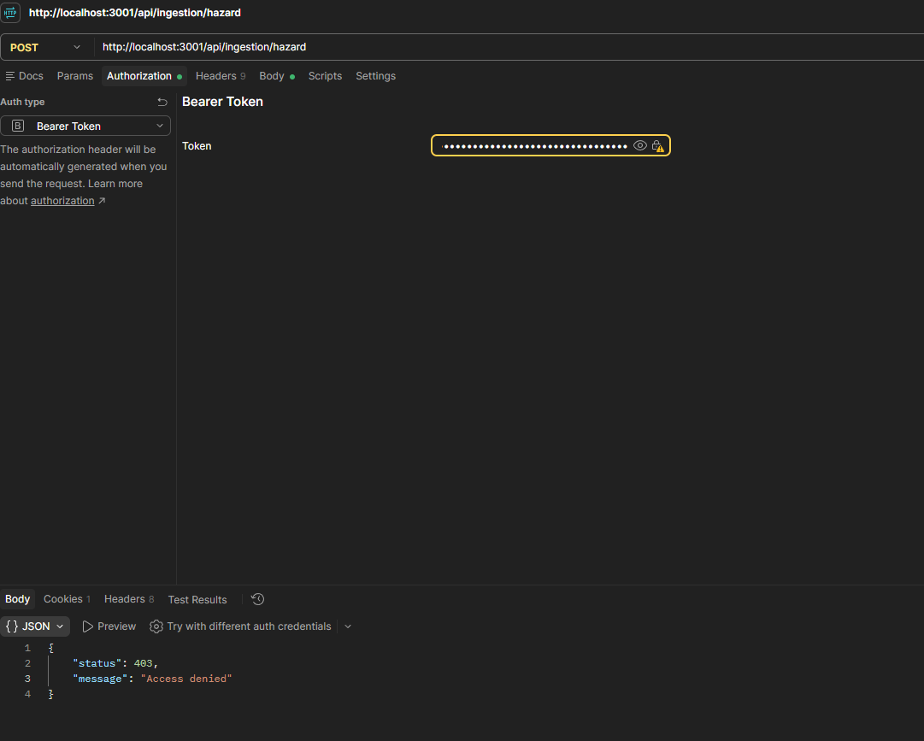
Figure 1 shows the ingestion service blocked form Hazard POST

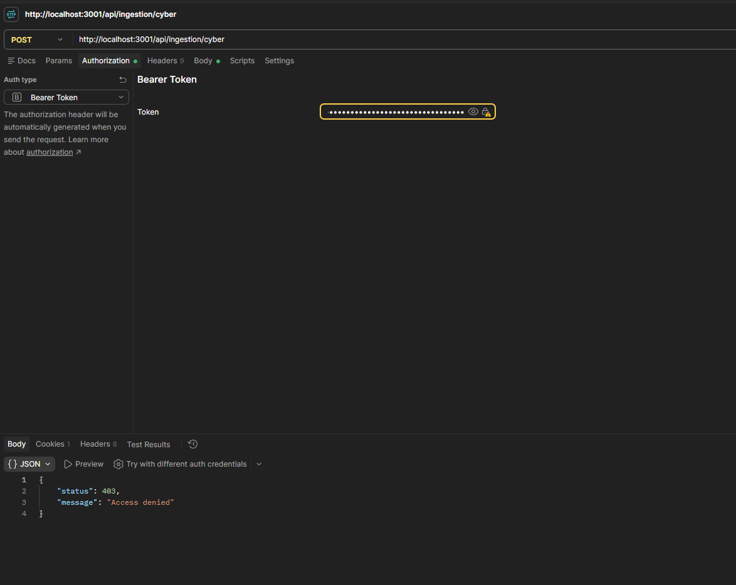
Figure 2 shows the ingestion service blocked form Cyber POST

- Admin role mismatch
I also found a mismatch with the admin role when testing the logout of another account. Based on the code, the admin should be able to log out of their own account or another account when testing this rule by using the admin account token and sending a logout request using the analyst account user ID. The request was blocked and returned “You are not authorized to log out this user.”

Role | endpoint | Expected | Actual
admin | /api/users/auth/logout | Allowed | Blocked

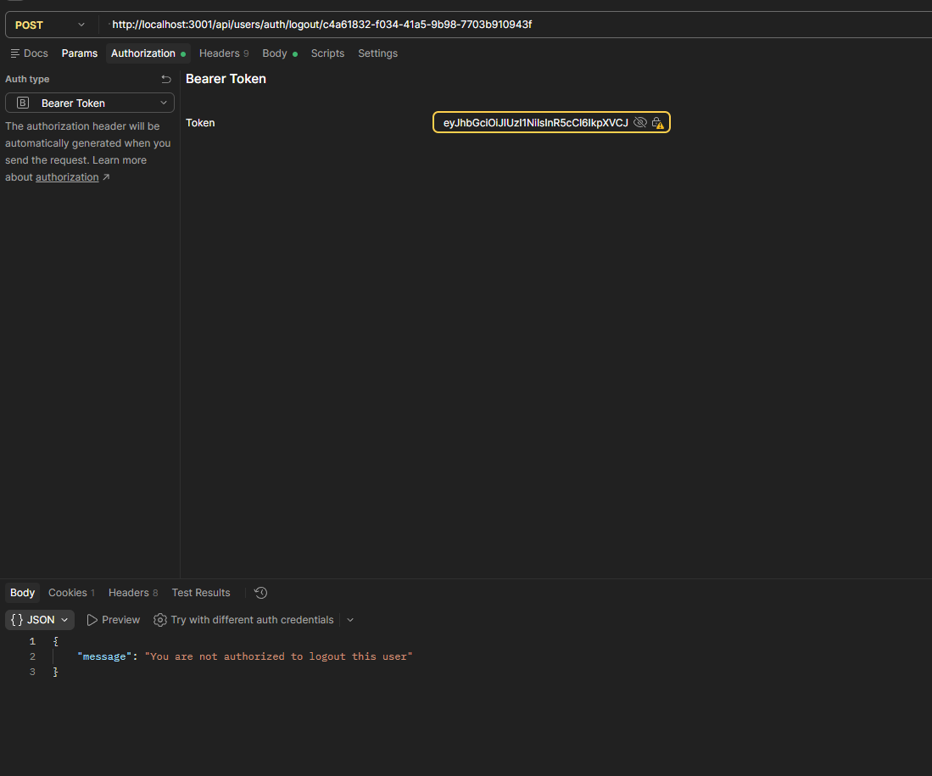
Figure 3 shows the admin is blocked from logging out of another account.

- Other observations

4.1- api/users/dashboard/overview
During the testing, the dashboard overview endpoint returned a 500 error for all four roles with the message "Error fetching dashboard overview.” The issue is not related to a specific role but rather an issue with the system.
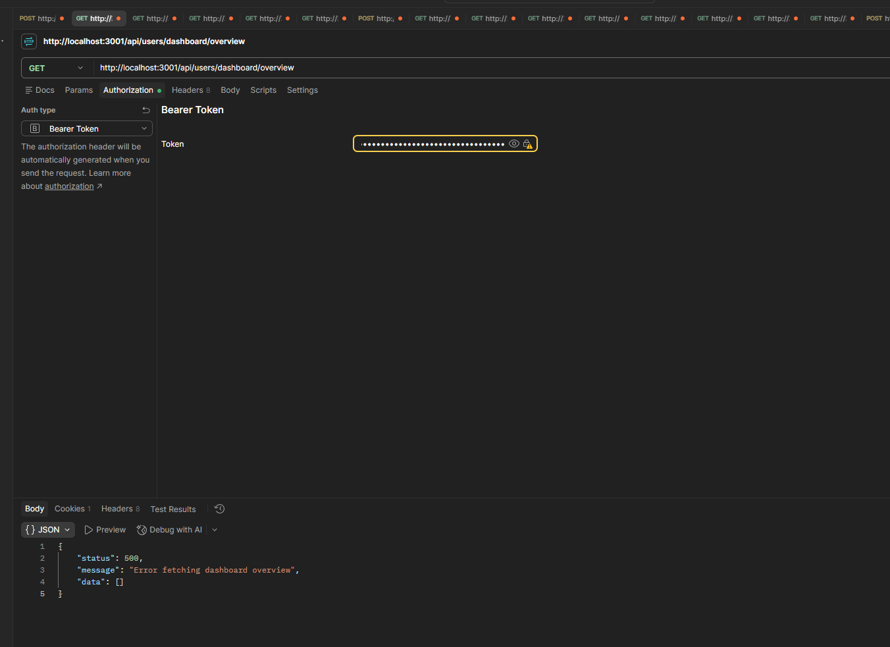

4.2- api/ingestion/core
Also, the Core POST endpoint accepted an empty request body and returned 202 Accepted with the message "Core model integration data sent successfully,” which means the endpoint does not check if the request contains data or not before sending.

